
Subject: Acceptance of CMSAs Code of Conduct to Protect Children

To CMSA,
I, Tarlochan Sidhu, director of the Lions soccer club and academic institution on behalf of the club, at this moment, acknowledge and accept the Code of Conduct to Protect Children set forth by the CMSA. I have thoroughly reviewed the document and am committed to adhering to the principles and guidelines outlined in the Code of Conduct.
I understand the importance of creating a safe and secure environment for children within the CMSA community. As a member of this organization, I am dedicated to upholding the highest standards of ethical behavior and ensuring the well-being and protection of children involved in any activities, programs, or events organized or supported by CMSA.
By accepting this Code of Conduct, I and all of the LSCA members pledge to:
- Prioritize the safety and welfare of children above all else.
- Follow all guidelines and protocols outlined in the Code of Conduct.
- Report any concerns, suspicions, or incidents related to child safety promptly to the appropriate authorities within CMSA.
- Foster an inclusive and respectful environment for children, free from discrimination, harassment, or harm.
I am aware that any violation of the Code of Conduct may result in appropriate action, including but not limited to disciplinary measures and legal consequences.
I appreciate the commitment of CMSA to the protection of children, and I am honored to be part of an organization that places such a high value on their well-being.
Thank you for the opportunity to contribute to the positive and safe environment that CMSA strives to maintain for children.
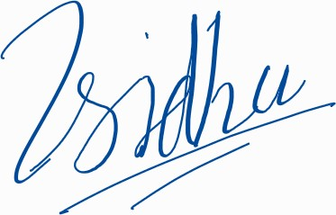
Sincerely,
Tarlochan Sidhu



